Custom Pipe

Create a class named custompipe.ts in app folder

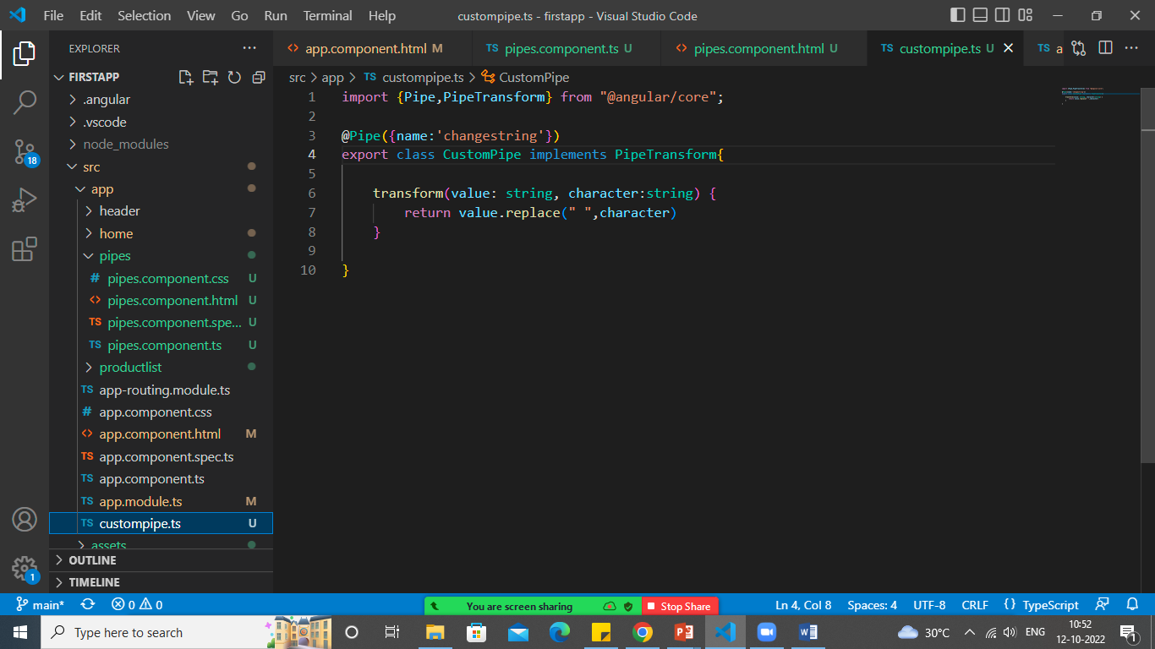

Register the pipe in app.module.ts

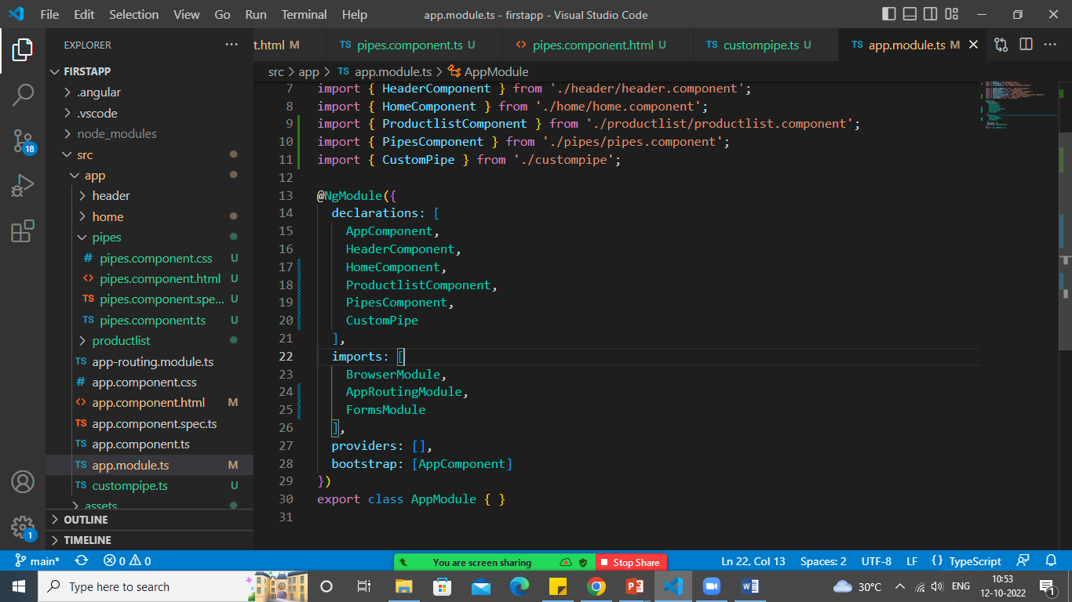

Use in your component

